Electro Actuated Solenoid Valves

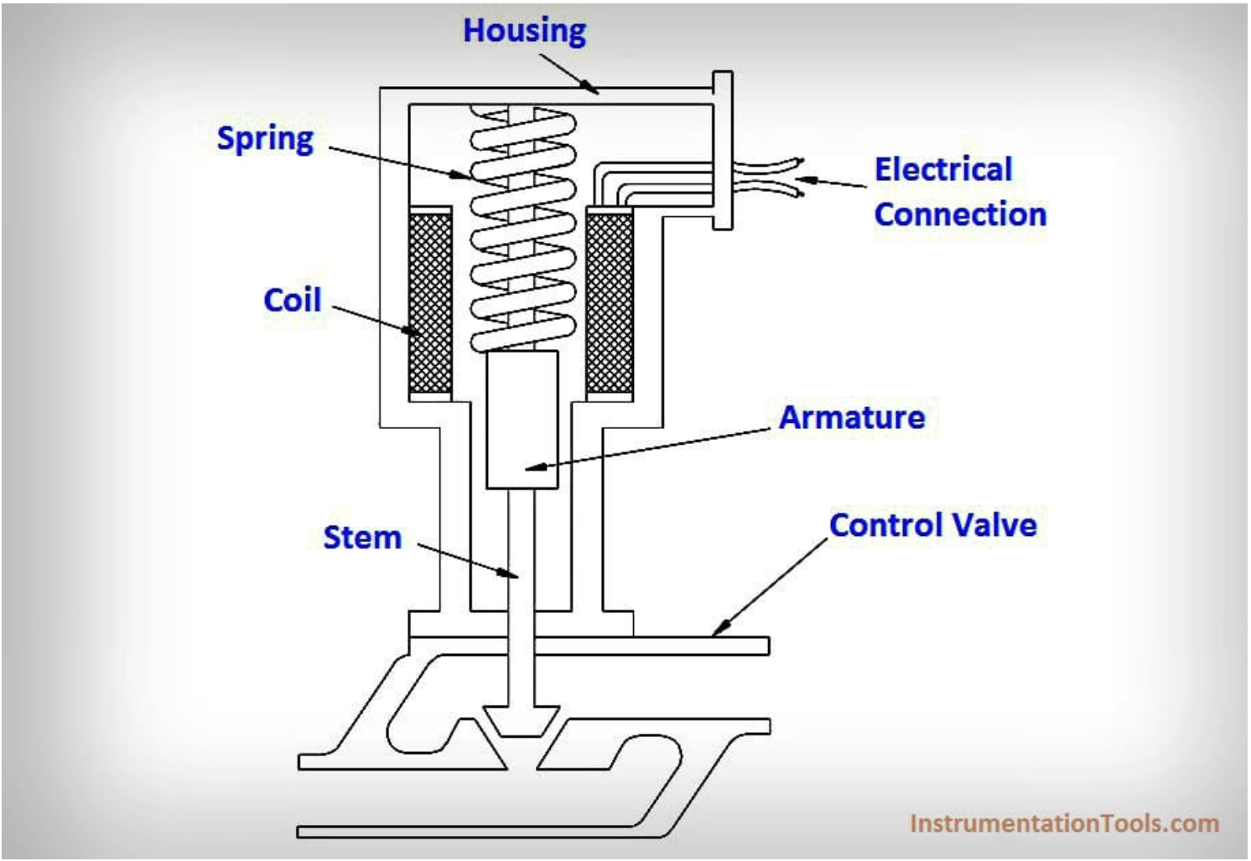

Electro Actuated Solenoid Valves consist of a series of components:

* Armature
* Actuator
* Plunger
* Spring

There are two types of valves. A Normally Closed Valve (NC) and a Normally Open Valve (NO). The Normally Closed Valve will be used.

**Normally Closed (NC)**

When current flows through the coil, a magnetic field forms around the coil. The magnetic field attracts the armature toward the center of the coil. As the armature moves upward, the spring collapses and the valve opens. When the circuit is opened and current stops flowing to the coil, the magnetic field collapses. This allows the spring to expand and shut the valve.

**Normally Open (NO)**

When current flows through the coil, a magnetic field forms around the coil. At this point the armature is in a open position upwards. In a normally open valve an electric current in the opposite direction will cause the armature to move downwards. As the armature moves downwards, the spring collapses and the valve closes. When the circuit is closed and current stops flowing to the coil, the magnetic field collapses. This allows the spring to open the valve.